 | Epsom and Ewell Local Plan  2022-2040  Post Hearing Documents Consultation Representation Form  Consultation date: Monday 11 May 2026 to  (23:59) Monday 15 June 2026 |  |  |  |  |  |  | 
Please email: localplan@epsom-ewell.gov.uk or return to: Planning Policy, Epsom and Ewell Borough Council, Town Hall, The Parade, Epsom, Surrey, KT18 5BY
Please note that copies of the comments received will be available for the public to view and cannot be treated as confidential. Data will be processed and held in accordance with the Data Protection Act 2018. Further information on how we handle your data can be found via the Privacy webpages on the Epsom & Ewell Borough Council website. Data Protection | Epsom and Ewell Borough Council
This form has two parts –
Part A – Personal Details: need only be completed once.
Part B – Your representation(s). Please fill in a separate sheet for each representation you wish to make.

Part A
1. Personal Details* |  |  |  |  |  |  | 2. Agent’s Details (if applicable)
*If an agent is appointed, please complete only the Title, Name and Organisation (if applicable)
boxes below but complete the full contact details of the agent in 2.
Title
First Name
Last Name
Job Title
(where relevant)
Organisation
(where relevant)
Address Line 1
Line 2
Line 3
Line 4
Post Code
Telephone Number
E-mail Address
(where relevant)

Part B – Please use a separate sheet for each representation

3. To which Additional Document does this representation relate? (please choose only one for each representation)

☒ Assessment of Urban Sites (COUD_020)
☒ Green Belt Topic Paper additional work (COUD_021)
☒ Additional Sites for Potential Allocation (COUD_029)
☒ Sustainability Appraisal (SA) Report Addendum (COUD_030)
☒ Habitats Regulations Assessment (HRA) Addendum (COUD_031)
☒ Infrastructure Delivery Plan (IDP) Addendum (COUD_032)
☒ Transport Assessment Addendum (COUD_033a)
☒ Transport Assessment Technical Annex Addendum (COUD_033b)

4. If your comment relates to a specific part of the document please identify this in the relevant section below:
Site  (if applicable) | NON016, NON042 | Page no. |  | Paragraph no. |  |  | Table/figure no.  (if applicable)
5. Please provide your comment(s) below:
Site reference: Downs Farm NON016
Related parcel: NON042
Epsom & Ewell Local Plan Additional Consultation

Main site objected to | Downs Farm (NON016)
Related parcel | NON042, treated in some documents as retained Green Infrastructure
Documents addressed | COUD_020, COUD_021, COUD_029, COUD_030, COUD_031, COUD_032, COUD_033a and COUD_033b
Requested modification | Remove Downs Farm (NON016) from the proposed additional allocations

Contents
- Executive Summary
- Cross-Cutting Issues Affecting Multiple Documents
- COUD_020 – Assessment of Urban Sites
- COUD_021 – Green Belt Topic Paper Addendum
- COUD_029 – Additional Sites for Potential Allocation
- COUD_030 – Sustainability Appraisal Addendum
- COUD_031 – Habitats Regulations Assessment Addendum
- COUD_032 – Infrastructure Delivery Plan Addendum
- COUD_033a – Transport Assessment Addendum
- COUD_033b – Transport Technical Annex
- Flooding, Drainage and Surface Water Concerns
- Biodiversity Evidence from Resident Observations
- Overall Conclusion and Requested Modifications
- Appendix A – Resident Photographic Evidence of Flooding
- Appendix B – Resident Photographic Evidence of Wildlife
- Appendix C – Heritage / Pillbox Evidence

Executive Summary
This representation objects to the proposed allocation of Downs Farm, identified in the consultation documents as site NON016 for housing, with the related southern parcel NON042 treated in some documents as retained Green Infrastructure.

The objection is not based on one isolated concern. The core issue is that the additional consultation documents do not provide a coherent, internally consistent, fully evidenced or adequately cumulative basis for releasing this sensitive Green Belt land. Taken together, the documents show an overwhelmingly undeveloped Green Belt site, weak public transport accessibility, significant settlement-separation harm, already stressed corridor infrastructure, unresolved flooding and drainage issues, biodiversity and landscape concerns, and heavy reliance on mitigation that remains aspirational rather than secured.

Downs Farm should not be allocated unless and until the Council has demonstrated, through robust evidence, that its Green Belt, transport, biodiversity, landscape, heritage, groundwater, flooding, infrastructure and safety impacts can be acceptably mitigated. The consultation documents do not do so.
The Council’s own evidence records Downs Farm as only 3.25% previously developed land and 96.75% undeveloped land. It also records weak accessibility and poor relative ranking compared with other sites. COUD_029 ranks Downs Farm poorly in accessibility terms and identifies the need for mitigation, while COUD_033a shows the site would remain car-dominant, with substantial vehicle movement onto the Reigate Road corridor. The evidence therefore does not support the conclusion that this is a sustainable or low-impact location.

The proposed allocation has generated exceptional public concern over a prolonged period. More than 14,000 individuals signed a petition calling for the protection of Epsom & Ewell’s Green Belt, including Downs Farm. Planning decisions should be based on planning merits rather than popularity; however, the scale of public engagement demonstrates the importance of this landscape to the local community and the strength of concern regarding its loss. It also highlights the contrast between the extensive public participation seen during earlier Local Plan stages and the relatively limited awareness of the current five-week consultation.

Resident photo evidence further illustrates local concerns. Photographs reported as taken on 06/02 show flooding and standing water along Reigate Road and adjoining footways/road edges. These images support residents’ concerns that existing highway drainage and pedestrian conditions are already poor during rainfall and that the consultation documents have not adequately assessed how a major greenfield allocation would affect surface water, road safety and walkability.
Additional resident photographs show wildlife observed on and around the farm and nearby area, including birds of prey, hedgehog and other bird species. These photographs do not replace formal ecological survey work, but they reinforce the need for proper site-specific biodiversity assessment before allocation.

The Inspector is respectfully asked to recommend that Downs Farm NON016 is removed from the proposed additional allocations.

Key Objections
- Greenfield and weakly accessible: Downs Farm is overwhelmingly undeveloped land, not a previously developed urban site, and performs poorly on the Council’s own accessibility evidence.
- Green Belt harm: The evidence depends heavily on the southern parcel NON042 remaining open, yet this safeguard is not robustly secured in the consultation bundle.
- Cumulative corridor impacts: The Reigate Road corridor(40m/h A road) is already under pressure and the documents do not adequately assess Downs Farm together with Priest Hill, NESCOT, Drift Bridge and other corridor pressures.
- Infrastructure uncertainty: The IDP acknowledges water, wastewater, education, SEND, healthcare and transport mitigation needs, but does not demonstrate that these are funded, secured or deliverable.
- Inconsistent evidence: The documents use different assumptions about yield, land uses, school/SEND provision, employment, bus service and mitigation.
- Environmental constraints: The package does not adequately assess flooding, groundwater, chalk aquifer, biodiversity, heritage, landscape or safety impacts.
- Changed judgement without clear audit trail: The Council has not clearly explained why Downs Farm, not previously allocated, is now being promoted through the post-hearing addendum process.

Cross-Cutting Issues Affecting Multiple Documents

1. The Evidence Base Is Internally Inconsistent
A recurring problem across the documents is that Downs Farm is described differently in different reports.

COUD_021 considers a promoter concept involving 675 homes plus parkland, school and employment uses. COUD_029 then identifies an indicative yield of 530 homes with possible specialist education and employment hub uses. COUD_033a models 530 dwellings only. These differences are not minor drafting inconsistencies. They affect transport generation, infrastructure requirements, education need, viability, mitigation, Green Belt balancing and Sustainability Appraisal conclusions.

There is also inconsistency regarding bus accessibility. Some documents describe the existing 166 bus provision as limited or infrequent, while other documents rely on it as a significant mitigation opportunity through possible rerouting or frequency improvement. The allocation case therefore depends on public transport assumptions that are not stable, secured or consistently evidenced.

2. Lack of Transparent Audit Trail for Changed Sustainability and Green Belt Judgements
A further concern is the lack of a clear audit trail explaining why Downs Farm has moved from not being included in the submitted Local Plan to now being promoted as a potential allocation through the post-hearing addendum process.

The Council had previously prepared Sustainability Appraisal and Green Belt evidence which did not result in Downs Farm being selected for allocation. The current addendum material now reaches a materially different planning outcome, yet it does not provide a clear, site-specific explanation of what has fundamentally changed to justify that shift.

This is particularly concerning because the Inspector had already identified shortcomings in the earlier Green Belt evidence, including inconsistent conclusions, errors in site assessment and unclear treatment of mitigation. In that context, the Council should have provided a transparent before-and-after comparison showing precisely how Downs Farm was previously assessed, how it is now assessed, what evidence has changed, and why any revised judgement is justified.
Instead, the current Sustainability Appraisal relies heavily on broad scenario-based commentary and planning judgement, with Downs Farm introduced as the major additional supply increase in Scenario 4. That approach does not allow residents or the Inspector to properly test whether the change in judgement is evidence-led or simply numbers-led.

The concern is reinforced by the Council’s own evidence. Downs Farm remains overwhelmingly undeveloped Green Belt land, has weak public transport accessibility, performs poorly in the Council’s accessibility scoring, and depends on the southern parcel remaining open to mitigate Green Belt harm. The current documents also rely on mitigation that is not secured, including possible bus rerouting, possible improved access to Epsom Downs Station and possible education provision. These are not new physical facts that make the site inherently more sustainable than before. They are assumptions about what might be delivered in the future.

The Council has therefore not adequately explained why Downs Farm should now be treated more favourably than in the earlier plan-making stages. In the absence of a clear audit trail, the revised assessment appears insufficiently transparent and insufficiently justified. This undermines the soundness of the proposed allocation, particularly under the “justified” test, which requires the Plan to be based on proportionate evidence and an appropriate strategy taking account of reasonable alternatives.

3. Failure to Assess Corridor-Wide Cumulative Impacts
The most important practical omission in the package is that it does not assess Downs Farm as a single-source issue. It assesses a selected plan package. Residents experience the Reigate Road corridor as a corridor, not as isolated sites. The Council’s own evidence already shows that this corridor is behaving cumulatively.
The Transport Addendum states directly that Nescot and Downs Farm both contribute to increased flow on A240 Reigate Road, with the largest increase up to 79 vehicles southbound in the AM peak and 71 vehicles northbound in the PM peak between A2022 College Road and the A24 Ewell By-Pass. It also records that the A240 Reigate Road deteriorates from C to D, that a number of main routes remain at D, and that critical junctions around the A24/A240/A2022 corridor remain at D/E/F even before detailed local assessment. (COUD_033a, pp. 43-53.) That is already a clear cumulative warning signal.

The Green Belt paper reinforces the corridor point from the opposite direction. It rejects Drift Bridge Farm NON021 because the site would breach a strong railway boundary, cause sprawl from the south, and create precedent for future creep. It explicitly says this would be harmful and that exceptional circumstances do not exist. (COUD_021, pp. 95-98, 120.) Yet Downs Farm sits nearby on the same broader corridor and is justified partly by existing ribbon development and partial separation retained through NON042. In practical terms, allocating Downs Farm would make resisting later releases nearby more difficult, not easier.

The SA Addendum itself acknowledges that Scenario 4 adds Downs Farm because it provides a major boost to supply, not because it is among the most sustainable locations. It also concedes that Downs Farm is a less accessible location within the borough, while noting concerns about the fragility of the remaining Green Belt gap. (COUD_030, pp. 19-20, 24-38.) In other words, the argument for allocation is numbers-led. Once that numerical precedent is established, corridor pressure on unallocated land intensifies.

The corridor need is therefore not just to compare one site with another. It is to ask a harder question: what happens if multiple Reigate Road corridor sites proceed over the plan period? The seven addenda do not answer that question.
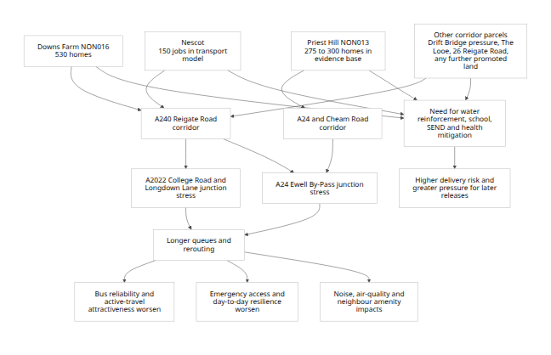
Because COUD_030 does not publish a simple numeric site-by-site SA score table for the 2026 uplift, a true “score change” bar chart for Downs Farm cannot be reproduced from the published addendum alone. The best auditable visual proxy is the step-change in total scenario housing supply caused by Scenario 4, which is Downs Farm alone.
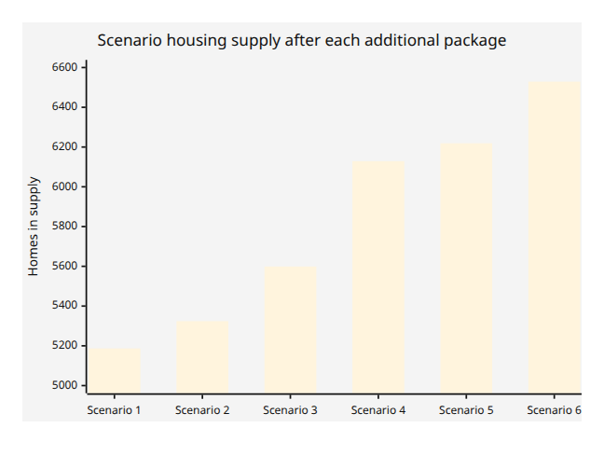
Scenario 4 is the only step in this sequence that adds 530 homes at once, and that step is Downs Farm. (COUD_030, pp. 19-20.) The policy importance of that jump is that the Council’s selection of NON016 is doing heavy work in closing the housing shortfall. That makes it even more important that the evidence for this site be robust, current-policy compliant, and corridor-cumulative. It is not.

Corridor comparison table
Site | Status in the seven documents | Main corridor / access relationship | Green Belt / openness issue | Traffic and transport issue | Flood / infrastructure issue | Delivery and cumulative risk
Downs Farm NON016 | Proposed additional allocation; 530 homes in COUD_029/030/033a | Direct onto A240 Reigate Road; relies on A2022/College Road and Longdown Lane linkages | 96.75% undeveloped; key role in the Epsom–Nork gap; justification relies on retaining NON042 as GI; Council accepts major merging effect but says it can be reduced (COUD_021, pp. 91-94, 119-120) | 65% AM / 68% PM car share; together with Nescot adds up to 79/71 vehicles on A240; A240 deteriorates to D; College Road/Longdown Lane remains stressed (COUD_033a, pp. 36-53) | Surface-water and groundwater issues noted; SES Water reinforcement likely; Thames Water capacity constraints acknowledged; secondary, SEND and health mitigation all needed (COUD_029, p. 48; COUD_032, pp. 4-18) | High: site definition and mitigation assumptions shift across documents; depends on bus re-route and station link not yet secured
Priest Hill NON013 | Proposed additional allocation in Scenario 3; 275 homes in COUD_029, but 300 homes + 114 jobs in COUD_033a | A24 / A232 / Cheam Road / Banstead Road corridor; near Ewell East | High Green Belt parcel score 8 but closer to station and urban edge than Downs Farm (COUD_021, pp. 87-90, 119-120) | Better rail/bus access than Downs Farm, but A24 severance and Cheam Road issues acknowledged; further mitigation needed (COUD_033a, pp. 34-36, 66-69; COUD_032, p. 4) | Borough-wide school, SEND and health pressures also apply; possible on-site SEND implications (COUD_032, pp. 10-14) | High in a different way: transport model and site allocation assumptions are inconsistent
Nescot | Not an additional housing allocation here, but transport model includes 150 jobs at Reigate Road | Same A240 Reigate Road corridor as Downs Farm | Large developed-site context; not the same openness issue as Downs Farm | Direct contributor with Downs Farm to Reigate Road corridor increases (COUD_033a, pp. 43-45) | Adds infrastructure demand and corridor movement | Important cumulative traffic factor that means Downs Farm is not a stand-alone corridor effect
Drift Bridge Farm NON021 | Assessed and rejected in COUD_021 | Same broad eastern corridor south-east of Downs Farm | Rejected because release would breach a strong railway boundary and encourage future creep (COUD_021, pp. 95-98, 120) | Not modelled as allocation in 033a because rejected | No corridor-wide sensitivity of a later revisit is tested | Strong precedent risk: allowing Downs Farm may weaken resistance to similar corridor releases later
Links Road and other live corridor parcels | No explicit cumulative assessment located in the seven addenda reviewed | Potential shared reliance on Reigate Road / local junction network | Not assessable from this bundle because they are largely absent from it | Not modelled here | Not assessed here | Their absence is itself a cumulative-impact omission if they remain live landowner interests

4. Consultation Timing and Public Awareness
The current consultation is short, technical and difficult for ordinary residents to engage with. It concerns major additional Green Belt sites and complex evidence documents, yet runs for only around five weeks.
This is materially different from earlier Regulation 18 and Regulation 19 stages, which involved broader publicity and longer periods of public engagement. Downs Farm was not presented to residents as a proposed allocation in the submitted Local Plan. Residents are therefore being asked to respond to a major new Green Belt release proposal late in the process and within a compressed timeframe.
The scale of earlier public concern, including the 14,000-signature petition, reinforces the importance of fair and meaningful consultation before irreversible Green Belt release is contemplated.

5. Failure to Adequately Consider Less Harmful Alternative Sites
The Council has not adequately demonstrated why Downs Farm should be selected ahead of less harmful alternatives.

Through COUD_020, the Council identified 13 additional urban sites capable of delivering approximately 193 homes. The majority comprise previously developed land or urban land, including commercial premises, retail sites, garages, hardstanding, business parks and other existing urban uses. Whilst this capacity may not be sufficient to meet all housing needs, it demonstrates that opportunities remain within the existing urban area.

Furthermore, the Council’s updated Green Belt assessment identified a number of smaller Green Belt sites considered capable of satisfying the relevant exceptional circumstances tests. The evidence does not clearly explain why one of the Borough’s largest and most environmentally sensitive Green Belt sites should be prioritised ahead of a combination of smaller, less harmful alternatives.

The Council’s own Sustainability Appraisal makes clear that Downs Farm’s principal attraction is its ability to deliver a large number of homes, approximately 530 dwellings, rather than any exceptional sustainability credentials. Downs Farm is also acknowledged to be the only major additional allocation option that has recently been in productive agricultural use. Development would therefore result in the permanent loss of open countryside and productive farmland, together with significant impacts on Green Belt openness, biodiversity, landscape character and the important gap between Epsom, Nork and Epsom Downs.

6. Core Planning and Soundness Conclusions
On the justified test, the case is weak. The PPG says every local plan must be informed and accompanied by SA, that SA should play a key role throughout plan-making, and that it is important in showing the plan has considered reasonable alternatives. It also says evidence should be proportionate, relevant and up to date, and that main modifications may require further SA and HRA. The bundle here does not provide a sufficiently stable or auditable basis for Downs Farm: site description, yield, jobs, school/SEND use, bus baseline, and dependency on NON042 all shift across documents. The SA Addendum does not provide a transparent numeric site-by-site scoring audit trail for the 2026 uplift; instead it relies heavily on qualitative scenario commentary and a broad strategic need to “boost” supply. (COUD_030, pp. 14-20, 22-38.)

On the effective test, delivery assumptions are not secured. The IDP Addendum records likely SES Water reinforcement, secondary school bulge provision, major SEND deficit, extra primary healthcare floorspace, and further sewage treatment assessment by Thames Water, while the transport addendum depends on a possible re-route of TfL’s 166 service and a possible direct Bunbury Way/Epsom Downs Station link. None of that is presented as funded, designed, timetabled or contractually secured. (COUD_032, pp. 4-18; COUD_033a, pp. 36-39, 66-69.) NPPF paragraph 36 requires effectiveness in delivery over the plan period, not a hope that mitigation can later be assembled.

On consistency with national policy, the key national tests on sustainable transport and flood risk are not met robustly enough. NPPF paragraph 116 says development should only be refused on highways grounds if the residual cumulative impacts, following mitigation, would be severe, taking account of all reasonable future scenarios. [6] But these addenda only test the Council’s selected package, not the fuller Reigate Road corridor build-out scenario that residents are rightly worried about: Downs Farm, Priest Hill, Nescot, 26 Reigate Road, The Looe/other Reigate Road parcels, Drift Bridge Farm pressure, and any further live promoted sites such as Links Road. The Council’s own transport evidence already shows the A240/A2022/A24 corridor is operating at or beyond comfortable capacity before those omitted sensitivities are fully tested. (COUD_033a, pp. 43-53, 59-69.)

On flood risk, national policy requires development to be directed away from areas at highest risk, a sequential risk-based approach to be used, and site-specific flood-risk assessment and SuDS to be applied where relevant. [7] Yet the package does not include a Downs Farm-specific FRA, drainage strategy, exceedance routing study, or highway drainage assessment even though the site profile shows surface-water and groundwater issues and the IDP itself describes surface water as the main flood-risk issue in the borough. (COUD_029, p. 48; COUD_032, pp. 9-10.)

A final procedural point is consultation fairness. PPG stresses early, proportionate and effective engagement, and confirms that the Inspector will require consultation on proposed main modifications, with further SA/HRA where necessary. Even without making a definitive legal point on the exact number of weeks, a compressed consultation on seven highly technical documents and major new Green Belt sites is plainly less accessible to ordinary residents than earlier, fuller plan stages. That is especially concerning where the documents themselves require cross-reading to understand what is actually proposed on Downs Farm.

COUD_020 – Assessment of Urban Sites
COUD_020 is relevant because it demonstrates that the Council has revisited discounted urban sites and identified additional urban capacity. The document concludes that 13 sites are developable over the Local Plan period, with an indicative yield of around 193 homes. These include sites such as 25 Alexandra Road, Parking at 54 Gainsborough Road, 85b Hook Road, Conservative Club, TK Maxx, Land rear of the Albion Public House, Spread Eagle Shopping Centre, Auction House Depot Road, Laine Theatre Arts and Eclipse Business Park. The Council’s SA Addendum also records that 54 urban sites were revisited, with 13 identified as potentially developable.

This does not mean that urban capacity alone can meet the whole housing requirement. However, it does demonstrate that additional urban and previously developed land opportunities remain available. Therefore, the Council should not treat Downs Farm as an unavoidable release simply because it provides a large single housing number.

The proper question is whether Downs Farm is the right site, not whether the Borough needs additional homes. COUD_020 supports the conclusion that the Council should continue to maximise urban and previously developed land opportunities before relying on a highly sensitive, largely undeveloped Green Belt site with major constraints.

COUD_021 – Green Belt Topic Paper Addendum
Relevant site reference: Downs Farm NON016 and related parcel NON042
Key pages: Downs Farm detailed assessment pp. 91-94; PDL/public transport summary pp. 111-120

Green Belt Harm and Settlement Separation
COUD_021 is central to the objection because it is the document that seeks to justify Green Belt release. However, its own evidence demonstrates why the allocation is highly problematic.
Downs Farm is overwhelmingly undeveloped Green Belt land. The Council’s evidence records it as only 3.25% previously developed land and 96.75% undeveloped land. The site also performs poorly on accessibility, with a low Regulation 18 MCA accessibility score. This is not a marginal urban infill site or previously developed parcel. It is a large greenfield release.
The site performs an important role in preventing the merging of settlements and maintaining the gap between Epsom and Nork. The Green Belt purpose of preventing neighbouring towns from merging is directly engaged.

The Council’s reasoning appears to accept that harm would arise but seeks to reduce that harm by relying on the southern parcel NON042 remaining open. This is a fundamental weakness. The southern parcel is not a peripheral landscape feature; it is doing much of the work in the Green Belt case. If the northern parcel is built out, the remaining openness and separation depend heavily on the continued protection of land outside the proposed housing allocation.
Existing erosion of a settlement gap is not a reason to permit further erosion. It is a reason to protect what remains.

2. Reliance on NON042 Remaining Open Is Not Adequately Secured
The entire conclusion depends on the southern parcel NON042 remaining open and functioning as Green Infrastructure. The paper says a gap of about 300m would remain between the northern parcel building line and the end of the southern parcel. That means the southern land is essential mitigation. However, the consultation documents do not demonstrate a robust long-term mechanism to secure that land permanently against future development pressure.

Once the northern parcel is urbanised, development pressure on the southern parcel is likely to increase. The Council’s own Sustainability Appraisal acknowledges concern that development of Downs Farm could increase pressure for future development of adjacent Green Belt land. This risk should be given significant weight.

The Inspector should not accept Green Belt mitigation that depends on a separate parcel remaining open unless that protection is secured through a clear and durable policy mechanism.

3. Impact on the Chalk Downs Landscape and the Setting of Epsom Downs Racecourse
Downs Farm is not simply an isolated agricultural field. It forms part of the wider open chalk landscape that provides an important transition between the urban edge of Epsom and the internationally recognised Epsom Downs. The site contributes to openness, rural character and visual separation between the built-up area and the Downs.

The significance of Epsom Downs extends beyond the racecourse itself. Epsom Downs is a nationally and internationally important sporting, cultural and landscape asset, best known as the home of the Derby. Its character derives not only from the racecourse facilities but also from its setting within a largely open chalk downland landscape. The approach to the Downs, long-distance views, the sense of openness and the relationship between the racecourse and surrounding countryside all contribute to its significance and public enjoyment.

Development of approximately 530 dwellings at Downs Farm would substantially urbanise one of the remaining open areas between Epsom and the Downs. The introduction of built form, roads, lighting, traffic, noise and infrastructure would permanently alter the character of the landscape and erode the transition from town to countryside. This would diminish the openness and setting of Epsom Downs and weaken the historic relationship between the racecourse, surrounding countryside and wider chalk downland environment.

The concern is amplified by the ecological and geological importance of the chalk landscape itself. Chalk grassland is one of the UK’s rarest habitats and forms part of a wider ecological network associated with the North Downs and Epsom Downs Biodiversity Opportunity Area. Once developed, this landscape cannot realistically be recreated. The loss would therefore extend beyond visual harm and affect the long-term integrity of a distinctive chalk downland landscape that contributes to the special character of Epsom and Ewell.

The consultation documents do not appear to contain a comprehensive assessment of the cumulative impact of this scale of development on the setting of Epsom Downs Racecourse, the openness of the Downs landscape, long-distance views, landscape character, or the wider chalk downland environment. In the absence of such evidence, the Council has not demonstrated that the allocation is justified or that the resulting harm has been properly understood and weighed against the claimed benefits of development.

4. Historic Environment, Heritage Assets and Conservation Area Impacts
A further concern is the potential impact on the historic environment. Downs Farm contains a surviving Second World War pillbox that formed part of the strategically important Outer London Defence Line, a defensive network constructed to protect London during the Second World War. This heritage asset is recorded in the national archaeological record maintained by the Archaeology Data Service.
Evidence link: Archaeology Data Service record for the pillbox

The significance of the site may extend beyond the pillbox itself, as it forms part of a wider historic military landscape. There have also been long-standing local accounts of possible wartime tunnels and associated defence infrastructure within the surrounding area.

In addition to the archaeological interest of the site itself, the proposed allocation is located in close proximity to designated heritage assets, listed buildings and the Higher Green / Longdown Lane Conservation Area. The Council’s own evidence acknowledges nearby heritage constraints but largely defers detailed assessment to later stages.

However, the purpose of the allocation process is to establish whether a site is suitable for development in principle. It is therefore necessary to understand not only direct impacts on heritage assets, but also impacts on their setting, significance, historic landscape character and views.

The consultation documents do not appear to contain any detailed archaeological assessment, geophysical survey, heritage impact assessment, or comprehensive evaluation of the wider military and historic landscape associated with Downs Farm. Nor do they adequately assess the potential effects of a major housing development on the setting of nearby listed buildings, the character and appearance of the Higher Green / Longdown Lane Conservation Area, or the historic relationship between Epsom Downs, the surrounding countryside and the built environment.

The Council has therefore not demonstrated that the archaeological, heritage and conservation impacts of development have been properly understood. Allocation of the site is premature until a full archaeological investigation and comprehensive heritage impact assessment have been undertaken.

5. Conclusion on COUD_021

COUD_021 does not provide a sound basis for releasing Downs Farm from the Green Belt. It acknowledges the importance of the settlement gap, relies on retained openness in NON042, and does not sufficiently address the wider landscape, heritage, chalk downs and Epsom Downs setting impacts.
Downs Farm should therefore be removed from the proposed additional allocations.

COUD_029 – Additional Sites for Potential Allocation
Document reference: COUD_029
Relevant site reference: Downs Farm NON016
Key pages: Downs Farm proforma pp. 47-49; conclusion and proposed list pp. 50-51

Downs Farm Is Not Demonstrated to Be a Sustainable Location

COUD_029 identifies Downs Farm (NON016) as a potential allocation of approximately 530 dwellings. However, the document itself highlights many of the constraints that make the site unsuitable.
The Council’s own assessment records that Downs Farm performs poorly in accessibility terms. The site ranks relatively low compared with alternative locations and remains heavily dependent on private vehicle travel. This is reflected in later transport evidence which shows the site to be strongly car-dependent despite proposed mitigation measures.

The allocation therefore conflicts with the objective of directing development towards the most sustainable locations. A site requiring extensive mitigation to overcome its inherent accessibility weaknesses cannot reasonably be regarded as one of the Borough’s most sustainable development options.

The Council appears to justify allocation primarily because the site delivers a large number of homes rather than because it performs particularly well against environmental, transport or sustainability criteria.

2. Failure to Properly Assess Cumulative Development Pressure Along Reigate Road
One of the most significant shortcomings of COUD_029 is its failure to assess Downs Farm within the wider context of development pressure along the Reigate Road corridor.

Downs Farm does not exist in isolation. Other sites either proposed, promoted, previously assessed, or identified through the Local Plan process include Priest Hill, NESCOT, Drift Bridge Farm, the Links Road area and other Green Belt landholdings adjacent to Reigate Road.

Residents experience these sites as part of the same corridor. The cumulative consequences include increased traffic congestion, pressure on local schools, pressure on healthcare services, increased demand for water and wastewater infrastructure, biodiversity fragmentation, increased flood risk and erosion of Green Belt openness.

The consultation documents consider individual sites but fail to demonstrate the combined effects of development occurring across the corridor. This omission is particularly important because the Council’s own evidence already demonstrates existing infrastructure constraints.

3. Risk of Future Development of the Southern Parcel (NON042)
The allocation strategy relies heavily upon the southern parcel remaining open. The Council repeatedly presents NON042 as Green Infrastructure that would mitigate Green Belt harm and preserve separation. However, the documents do not provide confidence that this protection will remain permanent.

Once development is established on the northern parcel, pressure for further development is likely to increase, the southern parcel becomes more vulnerable to future release, ecological value may diminish and the remaining settlement gap may be further reduced.

Residents are therefore concerned that the proposed allocation represents the first stage of a larger urban expansion rather than a final and permanent settlement boundary. The consultation documents do not adequately address this risk.

4. Productive Agricultural Land
The Council’s own Sustainability Appraisal acknowledges that Downs Farm is the only major additional allocation option that has recently been in productive agricultural use.
This distinguishes the site from many urban and previously developed alternatives. Development would result in the irreversible loss of productive farmland and open countryside.

Whilst food production may not be the primary purpose of Green Belt designation, the permanent loss of agricultural land should be weighed carefully when less harmful alternatives remain available. The consultation documents do not adequately justify why productive farmland should be sacrificed ahead of a more dispersed strategy involving previously developed land and smaller-scale allocations.

5. Safety, Health and Environmental Suitability Concerns
A further concern relates to the suitability of locating a major residential development, and potentially a SEND educational facility, adjacent to existing industrial and waste-related activities along the Reigate Road corridor. The Council's own evidence acknowledges the presence of a nearby waste management facility and identifies potential amenity concerns that would require further assessment. However, the implications of this relationship appear to have been deferred to later stages rather than properly evaluated as part of the allocation process.
The proposed SEND school is presented as a potential benefit of the scheme, yet no evidence has been provided to demonstrate that such a facility is funded, deliverable, supported by Surrey County Council, or compatible with neighbouring industrial activities. The surrounding area experiences regular heavy goods vehicle movements associated with waste, construction, logistics and other commercial operations. Residents have raised concerns regarding noise, dust, air quality, vehicle emissions and the potential presence of airborne particulates associated with recycling and construction-related activities. These issues require detailed investigation before the site can be considered suitable for sensitive uses such as a school for children with special educational needs and disabilities.
There are also wider highway safety concerns. Reigate Road is a busy 40mph A-road carrying substantial traffic volumes, including heavy goods vehicles. The development would require large numbers of new residents, including children, to cross or travel alongside this corridor in order to access Epsom Downs Station, bus services, schools, shops and community facilities. The consultation documents place significant weight on walking, cycling and public transport accessibility improvements, yet they do not adequately assess the practical safety implications of encouraging vulnerable users to travel along and across a heavily trafficked strategic road. The cumulative effect of additional residential traffic, industrial vehicle movements and increased pedestrian activity raises legitimate concerns regarding highway safety, particularly for children, elderly residents and those with disabilities.
In the absence of a comprehensive assessment of environmental health impacts, air quality, pedestrian safety, school suitability and cumulative HGV movements, the Council has not demonstrated that Downs Farm is an appropriate or safe location for the scale of development proposed.

6. Air Quality and Public Health Impacts
A further concern relates to existing air quality conditions along the Reigate Road corridor and the cumulative impact that additional development would have on public health.
An Environment Agency air quality monitoring study undertaken in the wider area identified significant particulate pollution concerns. The monitoring recorded PM10 concentrations exceeding Government daily air quality objectives on 82 occasions during the monitoring period, equivalent to an estimated 91 exceedances per year, compared with the permitted maximum of 35 exceedances per year. Maximum concentrations reached 148 μg/m³. The report also identified contributions from PM2.5 pollution associated with the A240 Reigate Road together with industrial activities, dust generation and vehicle movements.
PM10 refers to airborne particles smaller than 10 micrometres in diameter, while PM2.5 refers to even finer particles smaller than 2.5 micrometres. These particles are small enough to be inhaled deep into the respiratory system and are associated with respiratory illness, lung inflammation, asthma exacerbation, cardiovascular disease, stroke and premature mortality. Public Health England, the World Health Organisation and the UK Air Quality Strategy all recognise particulate pollution as a significant public health concern.
The concern is particularly relevant because Downs Farm is not being considered in isolation. The cumulative impact of development at Downs Farm, Priest Hill, NESCOT and other sites along the Reigate Road corridor would generate substantial additional vehicle movements on roads already identified as contributing to particulate pollution. The consultation documents assess transport impacts primarily in terms of capacity and congestion, but they do not appear to contain a comprehensive cumulative air quality assessment considering the combined effect of these developments on existing and future residents.
This issue is especially important in light of the proposed SEND educational facility, which would place children with additional needs in close proximity to a heavily trafficked corridor and existing industrial activities. The Council has not demonstrated that future residents, school users and vulnerable groups would be adequately protected from the cumulative effects of traffic-related air pollution and particulate emissions.
The Inspector should therefore require a comprehensive cumulative air quality and public health assessment before concluding that Downs Farm is a suitable and sustainable location for development.
7.Others
The document also materially shifts the scheme assumptions from COUD_021. In the Green Belt paper, the promoter concept was for 675 homes plus park, school and employment on the northern parcel with GI on the south. Here the site is reduced to 530 net dwellings, but the proposed use still refers to residential, employment hub, open space, specialist education provision (subject to need). (COUD_021, p. 91; COUD_029, pp. 47-49.) That lack of a stable proposal undermines every downstream assessment, including transport generation, infrastructure demand, viability and Green Belt balancing.

Flooding and drainage are not resolved. The site profile records 1.07% high, 1.61% medium and 2.85% low surface-water flood susceptibility, some groundwater vulnerability, and two sewer incidents within the predominant postcode. (COUD_029, p. 48.) Yet there is no site-specific FRA, no drainage layout, no exceedance-route plan, and no proof that highway runoff and downstream effects on Reigate Road have been modelled. The Council has not shown compliance with the plan-making requirement to consider cumulative flood effects in susceptible local areas, and has instead deferred critical matters to later planning applications. That is not enough where flood concern is one of the recognised local sensitivities and where the site is being used to justify permanent Green Belt release.

The paper also concedes a potential amenity issue from the adjoining waste management facility, and acknowledges proximity to the Higher Green/Longdown Lane Conservation Area and listed buildings, deferring the real answer to later stages. (COUD_029, pp. 47-49.) Allocation should not precede the evidence that determines whether the site is actually suitable.
There is a further internal inconsistency on the public-transport baseline. COUD_029 describes the 166 as a Monday-Friday hourly service, whereas COUD_033a describes it as operating three times an hour, and COUD_021 describes bus services as limited and infrequent. (COUD_021, pp. 92, 113-120; COUD_029, p. 48; COUD_033a, pp. 36-39.) If the baseline is not stable, the mitigation case is not reliable.

COUD_030 – Sustainability Appraisal Addendum
Document reference: COUD_030
Relevant site reference: Downs Farm NON016
Key pages: site option discussion pp. 14-20; scenario table p. 20; appraisal discussion pp. 22-38
The SA Addendum does not justify Downs Farm through a transparent reappraisal of reasonable alternatives. Instead, it treats the site as a major numerical uplift and then smooths over the consequences through high-level, qualitative scenario commentary that is too coarse and too opaque for a Green Belt release of this scale

1. Failure to Explain Changed Sustainability Conclusions
One of the most serious concerns regarding COUD_030 is the absence of a clear explanation for why Downs Farm has moved from being excluded from the Local Plan to being promoted as a preferred option.

The Council previously prepared Sustainability Appraisal evidence that did not result in Downs Farm being allocated. The current Sustainability Appraisal reaches a materially different conclusion. However, the Council does not provide a clear comparison of previous and current scores, a transparent explanation of changes, evidence showing what new information has emerged, or justification for revised conclusions.

The result is that neither residents nor the Inspector can properly understand how the Council has arrived at a fundamentally different planning judgement. The process appears insufficiently transparent and raises legitimate concerns regarding whether the revised conclusions are evidence-led or housing-number-led.

2. Scenario 4 Appears Driven Primarily by Housing Numbers
The Sustainability Appraisal identifies Downs Farm as a key component of Scenario 4. The principal advantage of Downs Farm appears to be that it provides approximately 530 homes.
However, the document does not demonstrate that Downs Farm is environmentally superior to alternatives. Indeed, the evidence identifies numerous concerns including Green Belt harm, accessibility weaknesses, landscape impacts, biodiversity impacts, settlement separation concerns and infrastructure pressures.

The allocation therefore appears to derive largely from housing yield rather than sustainability performance. A Sustainability Appraisal should demonstrate why a site is sustainable. It should not simply justify a site because it produces a large housing number.

The document acknowledges significant weaknesses but does not let them meaningfully affect the outcome. It accepts that Downs Farm is a less accessible location within the borough, that the remaining Green Belt gap is fragile, and that development could create pressure for future development in adjacent parcel NON042. (COUD_030, pp. 26-38.) Yet the qualitative appraisal still treats Scenarios 1-4 as broadly on a par under some topics, especially biodiversity and climate adaptation. That is not a convincing depiction of what a 530-home step change does in practice.

3. Biodiversity Concerns Have Been Underestimated
The ecological importance of Downs Farm appears to have been underestimated throughout the assessment process.

Residents have recorded a variety of species on and around the site, including birds of prey, hedgehogs, bats, skylarks, deer, newts and a range of woodland and farmland bird species. Photographic evidence gathered by local residents demonstrates the presence of wildlife in and around the site.
The attached photographs include birds of prey observed locally, hedgehog records and other notable bird species associated with the wider landscape. Whilst these observations do not replace professional ecological surveys, they reinforce concerns that the site supports a diverse ecological network.
The Council should not assume absence of ecological value simply because a site is agricultural.

4. Chalk Grassland and Biodiversity Opportunity Area
Downs Farm forms part of the wider chalk landscape associated with Epsom Downs. Chalk grassland is one of Britain’s rarest habitats. The site contributes to the ecological network associated with Epsom Downs, the North Downs and local Biodiversity Opportunity Areas.
Development would result in habitat fragmentation and increased urban pressure on surrounding ecological resources. Once lost, chalk downland cannot realistically be recreated within the lifetime of the Local Plan.

The Sustainability Appraisal does not adequately reflect the long-term significance of this loss.

5. Failure to Assess Community and Recreational Value
The Sustainability Appraisal places considerable emphasis on housing delivery. However, it gives insufficient weight to landscape value, recreational value, community identity and wellbeing benefits.
The scale of public concern, including the petition signed by more than 14,000 individuals, demonstrates the importance of the site to local residents. Whilst planning decisions should not be determined by popularity, such exceptional levels of engagement indicate that the landscape provides substantial social and community value which deserves greater recognition.
7. The document uses earlier evidence selectively and inconsistently.
It says scenarios must be based on proportionate evidence, but it also progresses some other sites “on balance” despite failing the Calverton tests, largely because of strategic context. (COUD_030, pp. 15-18.) This is an example of the judgment concern raised by residents: the addendum changes the overall planning balance without an equivalently transparent change in underlying evidence.

COUD_031 – Habitats Regulations Assessment Addendum

1. Narrow Scope of Assessment
First, the scope is confined to European sites. That is what HRA is for, but it means the report does not answer local biodiversity, local recreational pressure, BOA connectivity or Green Belt landscape-function questions at Downs Farm. The SA Addendum itself acknowledges the strategic importance of the North Downs/Epsom Downs BOA, pressure on NON042, and the possibility of future development creep. (COUD_030, pp. 26-27.) COUD_031 does not resolve those local issues.
Second, the air-quality AA is very narrow. It is focused on the B2032 near the Mole Gap to Reigate Escarpment SAC, and the AQ update says the additional allocations have no plausible reason to cause a significant increase there. (COUD_031, pp. 9-10 and Appendix A.) That says nothing about A240 Reigate Road, A24 Ewell By-Pass, or other local corridor exposure, which is where Downs Farm’s real traffic effect sits.

Third, the water and wastewater conclusion is high-level rather than site-specific. The report relies on the broader regulatory framework and Local Plan policy wording to conclude no European-site harm from water quantity. (COUD_031, pp. 10-11.) But the IDP Addendum confirms likely reinforcement requirements for Downs Farm and Priest Hill and acknowledges sewage-treatment capacity constraints. (COUD_032, pp. 6-7.) So HRA is not a proxy for deliverability.

Fourth, the document is not a complete answer even within the wider scenario structure. The SA Addendum notes that recent HRA work covered scenarios up to Scenario 5, not the higher scenario. (COUD_030, p. 27.) That highlights the staged and partial nature of the environmental work being asked to justify this late package.

2. Potential Future Pressure on Adjacent Green Infrastructure
The HRA assumes that surrounding Green Infrastructure and ecological land remain available. However, the allocation itself may create future pressure for additional development.

The Council’s own evidence recognises concern regarding the long-term protection of adjacent open land. If the southern parcel NON042 were ever developed, the ecological consequences could be substantially greater than those currently assessed. The HRA does not fully explore this risk.

3. Precautionary Principle
Given the scale of development proposed, the sensitivity of the surrounding chalk landscape, the evidence of wildlife recorded locally, and the uncertainty surrounding future pressures on adjacent land, a precautionary approach is justified.

The Council should undertake more detailed ecological assessment before concluding that the allocation is environmentally acceptable.

Conclusion on COUD_029, COUD_030 and COUD_031
Taken together, these documents do not demonstrate that Downs Farm is a sustainable allocation. The evidence instead shows significant environmental constraints, unresolved biodiversity concerns, poor accessibility, reliance on uncertain mitigation, insufficient explanation for changed assessment conclusions, and failure to properly assess cumulative impacts.
The documents therefore do not provide a robust basis for releasing Downs Farm from the Green Belt.

COUD_032 – Infrastructure Delivery Plan Addendum
Document reference: COUD_032
Relevant site reference: Downs Farm NON016
Key pages: transport pp. 4-5; utilities/flood pp. 6-10; education/health pp. 10-18

1. Infrastructure Constraints Are Acknowledged but Not Resolved
COUD_032 is notable because it acknowledges a range of infrastructure pressures associated with the proposed allocation. However, acknowledgement of a problem is not the same as demonstrating that the problem can be solved.

The document identifies potential pressures relating to water supply, wastewater treatment, healthcare provision, education, SEND provision and transport infrastructure. In many cases the proposed solution is limited to future developer contributions, further discussions, future studies or possible mitigation.
The document therefore demonstrates infrastructure dependency rather than infrastructure readiness. The Inspector should be cautious about allocating a large Green Belt site where essential infrastructure remains uncertain.

2. Water Supply Constraints
The IDP records that SES Water has identified likely reinforcement requirements associated with Downs Farm and Priest Hill. This is significant. The need for reinforcement indicates that existing infrastructure may not be sufficient to accommodate development without intervention.

Yet the consultation documents do not provide a delivery programme, confirmed funding, detailed engineering solutions, or implementation timescales. The allocation therefore depends on future infrastructure upgrades that remain uncertain.

3. Wastewater Capacity Constraints
The IDP also records concerns regarding wastewater treatment capacity. The documents acknowledge that the relevant wastewater network and treatment infrastructure may require enhancement to accommodate additional growth.

Again, however, the consultation documents stop short of demonstrating that capacity exists, that upgrades are funded, or that upgrades are deliverable within the Local Plan period. This uncertainty should weigh against allocation.

4. Groundwater, Chalk Aquifer and Water Resource Concerns
A major omission from the consultation package is the absence of a detailed hydrogeological assessment.

Downs Farm lies within the chalk landscape associated with the North Downs groundwater system. Chalk geology is highly permeable and plays an important role in groundwater storage and recharge.
The Council’s evidence acknowledges groundwater sensitivity but does not appear to provide a site-specific hydrogeological assessment, groundwater recharge modelling, infiltration studies, groundwater quality assessment, Source Protection Zone assessment, or assessment of cumulative impacts on groundwater resources.

Large-scale urbanisation introduces roads, drainage systems, construction activity, vehicle runoff, potential pollutants and reduced natural infiltration. These can affect groundwater quality and groundwater recharge.

Whilst it may not be possible to demonstrate that Downs Farm sits directly above a strategic public water supply abstraction point, the Council has not demonstrated the opposite either. The absence of evidence should not be interpreted as absence of risk.

Given the acknowledged need for water network reinforcement and the site’s chalk geology, the Inspector should require further hydrogeological assessment before allocation is considered sound.

5. Education and SEND Provision
Secondary places are in deficit up to 2031 and 500+ homes on Downs farm would make the situation much worse. In addition, the consultation documents repeatedly refer to the possibility of a SEND school. However, the evidence does not demonstrate that a provider exists, that funding exists, that Surrey County Council supports the proposal, that a need assessment has been undertaken, or that delivery is secured.
The SEND school therefore appears speculative. The Council should not rely on a speculative facility as a justification for Green Belt release.

If the SEND facility is central to the planning balance, its deliverability must be demonstrated. If its deliverability cannot be demonstrated, it should carry limited weight.

6. Transport
On transport, the report says the cumulative impact is “in general tolerable” and “not considered severe”, but it relies on the strategic transport model and immediately follows that by acknowledging both site-specific and cumulative mitigation needs. (COUD_032, pp. 4-5.) For Downs Farm, the actual proposed mitigations are only potential re-routing of the 166 and a direct connection to Bunbury Way/Epsom Downs Station. Those are opportunities, not committed schemes. TfL’s own response says there may be a case for increased frequency, that planning obligations would be needed, and that bus standing and driver facilities are a barrier. (COUD_032, pp. 4-5.) That is not a secured mitigation package.

7.Others
On health, the report says extra primary healthcare floorspace will be needed. (COUD_032, pp. 13-14.) On acute care, no response was received from Epsom and St Helier University Hospitals Trust. (COUD_032, p. 14.) So the package is plainly incomplete on healthcare.
On flood risk, the addendum remains generic. It reiterates broad flood-risk management principles and the borough-wide surface-water issue, but does not provide a Downs Farm site-specific drainage solution. (COUD_032, pp. 9-10.)

COUD_033a – Transport Assessment Addendum
Document reference: COUD_033a
Relevant site reference: Downs Farm
Key pages: Downs Farm routeing pp. 36-39; link/junction analysis pp. 43-53; cross-boundary and conclusions pp. 59-69

1. Downs Farm Remains a Car-Dependent Development
The Transport Assessment demonstrates that Downs Farm would remain strongly dependent on private vehicles. The Council’s own modelling shows a high proportion of trips being made by car. The model assigns Downs Farm a 65% AM and 68% PM car mode share, with only 9% active-mode share in both peaks. (COUD_033a, pp. 36-39.)

This is inconsistent with the objective of locating growth in highly sustainable locations. The site’s accessibility weaknesses are not removed simply because mitigation measures are proposed. The evidence instead confirms that car use will remain the dominant travel mode.

2. Reliance on 2019 Transport Data
A major concern is that the modelling relies upon a 2019 base year. Since 2019, commuting patterns, population composition, rail usage and travel behaviour have changed.

The Council has not demonstrated that 2019 travel patterns accurately reflect conditions in 2026. This is particularly important in a commuter borough such as Epsom & Ewell.

The Inspector should attach limited weight to forecasts based on pre-pandemic assumptions unless the Council can demonstrate that those assumptions remain representative.

3. Existing Congestion Is Already Severe

The Transport Assessment itself identifies existing pressures on the highway network. Particular concern exists regarding Reigate Road (A240), Longdown Lane, College Road, Cheam Road and Ewell By-Pass junctions.

Several junctions already operate under significant stress. The modelling demonstrates that additional development increases pressure further. This is particularly concerning because Downs Farm is not the only development proposal affecting the corridor.

4. Failure to Properly Assess Cumulative Corridor Impacts
The Transport Assessment largely evaluates Downs Farm and NESCOT within specific modelling scenarios. However, residents are concerned about the cumulative impact of Downs Farm, Priest Hill, NESCOT, Drift Bridge area sites and other promoted Green Belt sites.
The combined effect of these developments could be substantially greater than the effects assessed. The evidence does not adequately demonstrate that the Reigate Road corridor can accommodate this level of cumulative growth.

The report states that Nescot and Downs Farm directly contribute to increases on A240 Reigate Road, with increases of up to 79 vehicles southbound in the AM and 71 vehicles northbound in the PM between A2022 College Road and A24 Ewell By-Pass. (COUD_033a, pp. 43-45.) It further identifies the A240 Reigate Road as one of the roads deteriorating from C to D, and highlights it as a route that provides access to both the Nescot and Downs Farm sites. (COUD_033a, pp. 47-49.)
The existing network is already stressed. The report shows the A2022 College Road / Longdown Lane junction at E in the AM peak and D in the PM peak; the A24 Ewell By-Pass / Cheam Road / A232 junction at F; and the A24 Ewell By-Pass / Epsom Road junction worsening from C to D. (COUD_033a, pp. 50-53.) That is a fragile base condition before any detailed junction modelling for a Downs Farm planning application.

Cross-boundary effects matter too. The report identifies A240 Reigate Road entering the borough in the PM peak as +58 vehicles, and says this is a direct Local Plan effect because of the Downs Farm site’s location. (COUD_033a, pp. 59-62.) That means the impact is not confined to the site frontage; it spreads across the corridor and authority boundary.

5. Highway Safety Concerns
Reigate Road is a busy 40mph A-road carrying substantial traffic volumes. The road is used by commuters, buses, heavy goods vehicles, industrial traffic and construction traffic.

The proposed development would significantly increase the number of pedestrians, cyclists and vulnerable users required to travel along or across this corridor. This includes children, elderly residents, disabled residents and SEND pupils if the proposed school were delivered.

The Transport Assessment places considerable emphasis on walking and public transport. However, it does not adequately assess whether the routes required to achieve those travel patterns are attractive, convenient and safe in practice.

The allocation therefore raises significant concerns regarding pedestrian safety and accessibility.

6.Others
NPPF paragraph 116 requires judgment on the residual cumulative impacts following mitigation and taking account of all reasonable future scenarios. [6] Yet the report does not test the full corridor build-out concern that residents have identified. It tests the Council’s selected package only. Nor does it secure the critical mitigation. Nor does it override the report’s own caveat that detailed local transport assessments will still be needed because the model is strategic. (COUD_033a, p. 5 and pp. 66-69.)

There is also an important inconsistency in assumptions. COUD_033a’s Table 1 models Land at Priest Hill as 300 dwellings and 114 jobs, while COUD_029’s Table 7 lists Priest Hill as 275 C3 units with no job figure. (COUD_029, pp. 50-51; COUD_033a, pp. 9-10.) If the evidence base is inconsistent on one major site, it weakens confidence in the cumulative modelling package as a whole.

Requested change. Do not rely on COUD_033a to allocate Downs Farm. The proper response to this report is a corridor-specific reassessment of the A240/A2022/A24 network, including sensitivity testing for other live corridor sites and a detailed junction package before any allocation.

COUD_033b – Transport Technical Annex
Document reference: COUD_033b
Relevant site reference: Downs Farm appears in the forecast schedule; the main relevance is methodological
Key pages: validation and limitations pp. 41-49; flow validation appendix around p. 54; forecast method pp. 41-49

1. Technical Modelling Does Not Reflect Everyday Experience
Residents experience frequent congestion along Reigate Road, Longdown Lane, Cheam Road and Drift Bridge area junctions.

Whilst modelling is useful, the lived experience of residents suggests that network resilience is already limited. The addition of several hundred dwellings is therefore likely to have a more noticeable impact than suggested by strategic modelling outputs.

Most importantly for residents near Downs Farm, the annex acknowledges that the model is strategic and that local junction validation may be required if outputs are to be used in detailed junction assessments, adding that individual developments will still need detailed local transport assessments. (COUD_033b, pp. 41-44.) That directly undercuts any suggestion that this annex settles the Reigate Road/Longdown Lane issue.

There is also a corridor-specific validation concern. In the appendix flow-validation tables, one AM count on A240 Reigate Road south-to-north shows modelled flow 174 vehicles higher than observed, a 35% difference and GEH 7.23, which is outside ideal validation tolerances. The reverse direction performs better, but the point stands: even on the very corridor where Downs Farm matters, the model has notable variance at at least one count location. (COUD_033b, Appendix flow validation around p. 54.)

2. Pressure on Rail Infrastructure
The documents place weight on access to rail services. However, Epsom Downs Station provides relatively limited services, many commuters are likely to prefer Ewell East or Ewell West, and journeys to those stations often require car travel.
The evidence does not adequately examine whether the assumed public transport mode share is realistic.

Flooding, Drainage and Surface Water Concerns

1. Resident Evidence of Existing Flooding
Residents have submitted photographic evidence showing flooding and standing water along Reigate Road and adjoining footpaths during rainfall events.

The photographs reported as taken on 06/02 show standing water on the carriageway, flooded road edges, water accumulation adjacent to footways and vehicles generating spray through pooled water. These images suggest that parts of the corridor already experience drainage difficulties.
The photographs should be treated as supporting evidence of local conditions and should be considered alongside technical drainage and flood-risk evidence.

2. Risk of Increased Surface Water Runoff
Downs Farm currently functions as predominantly open land. Development would replace permeable surfaces with roads, roofs, hardstanding and associated infrastructure.

Even with sustainable drainage systems, some change in runoff characteristics is inevitable. The consultation documents do not adequately demonstrate that downstream impacts have been fully assessed.

Residents therefore remain concerned that development could exacerbate existing drainage and flooding problems.

Biodiversity Evidence from Resident Observations
Residents have recorded a range of wildlife species on and around Downs Farm and the surrounding area. Photographic evidence includes birds of prey, hedgehogs, woodland birds and wetland-associated bird species. Residents have also reported sightings of bats, skylarks, deer and newts.
Whilst these observations do not replace formal ecological surveys, they demonstrate that the landscape supports a functioning ecological network and should not be regarded as low-value agricultural land.
The Council should undertake more detailed ecological assessment before concluding that the site is suitable for allocation.

Overall Conclusion and Requested Modifications
The consultation documents do not provide a sound basis for allocating Downs Farm (NON016). Taken together they demonstrate substantial Green Belt harm, dependence on NON042 remaining undeveloped, loss of productive agricultural land, impacts on the chalk downs landscape, harm to the setting of Epsom Downs Racecourse, unresolved biodiversity concerns, heritage and conservation concerns, groundwater and aquifer uncertainty, infrastructure constraints, transport pressures, flood and drainage concerns, highway safety concerns, insufficient explanation for changed Sustainability Appraisal and Green Belt conclusions, and failure to assess cumulative impacts across the wider Reigate Road corridor.

The evidence also relies heavily upon future mitigation that is not secured, funded or guaranteed to be delivered. Accordingly, Downs Farm has not been demonstrated to be the most appropriate, sustainable or justified location for growth.

The Inspector is therefore respectfully requested to recommend that Downs Farm (NON016) be removed from the proposed additional allocations.

Appendix A – Resident Photographic Evidence of Flooding
The following photographs are resident evidence showing flooding and standing water along Reigate Road and adjoining road edges / footways. They are included as supporting evidence of existing drainage, walkability and highway safety concerns. They do not replace a technical flood-risk assessment, but reinforce the need for one before allocation.

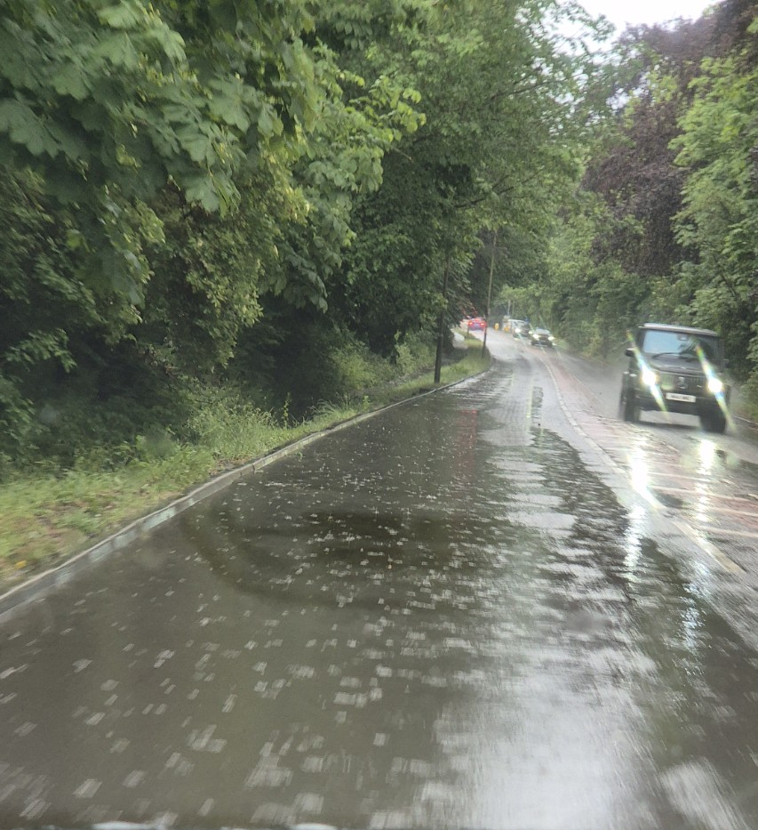
Flooding and standing water on Reigate Road, reported as taken on 06/02.

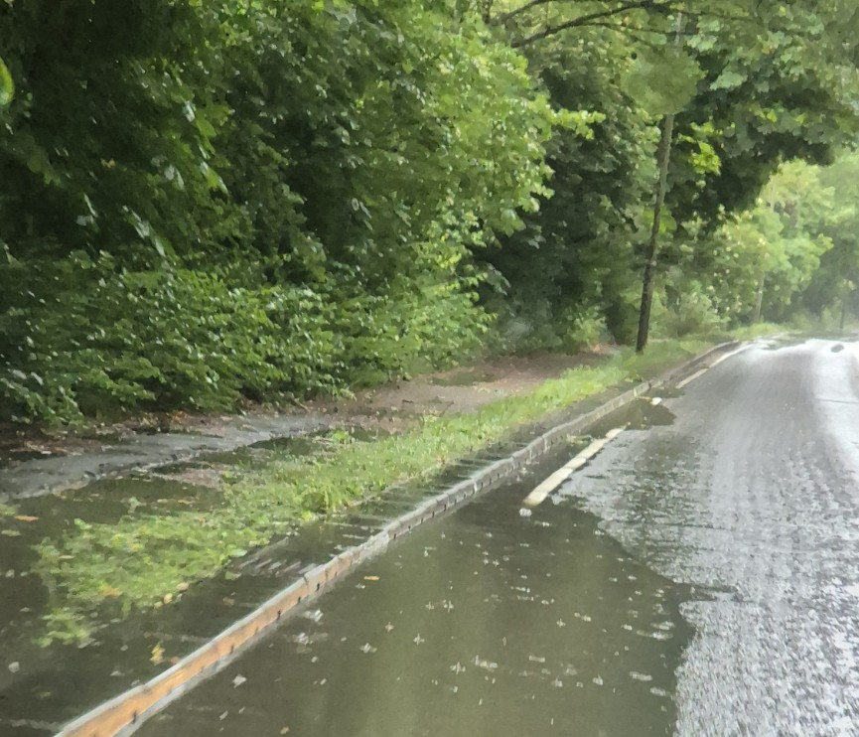
Standing water at the road edge and adjoining footway / verge, reported as taken on 06/02.
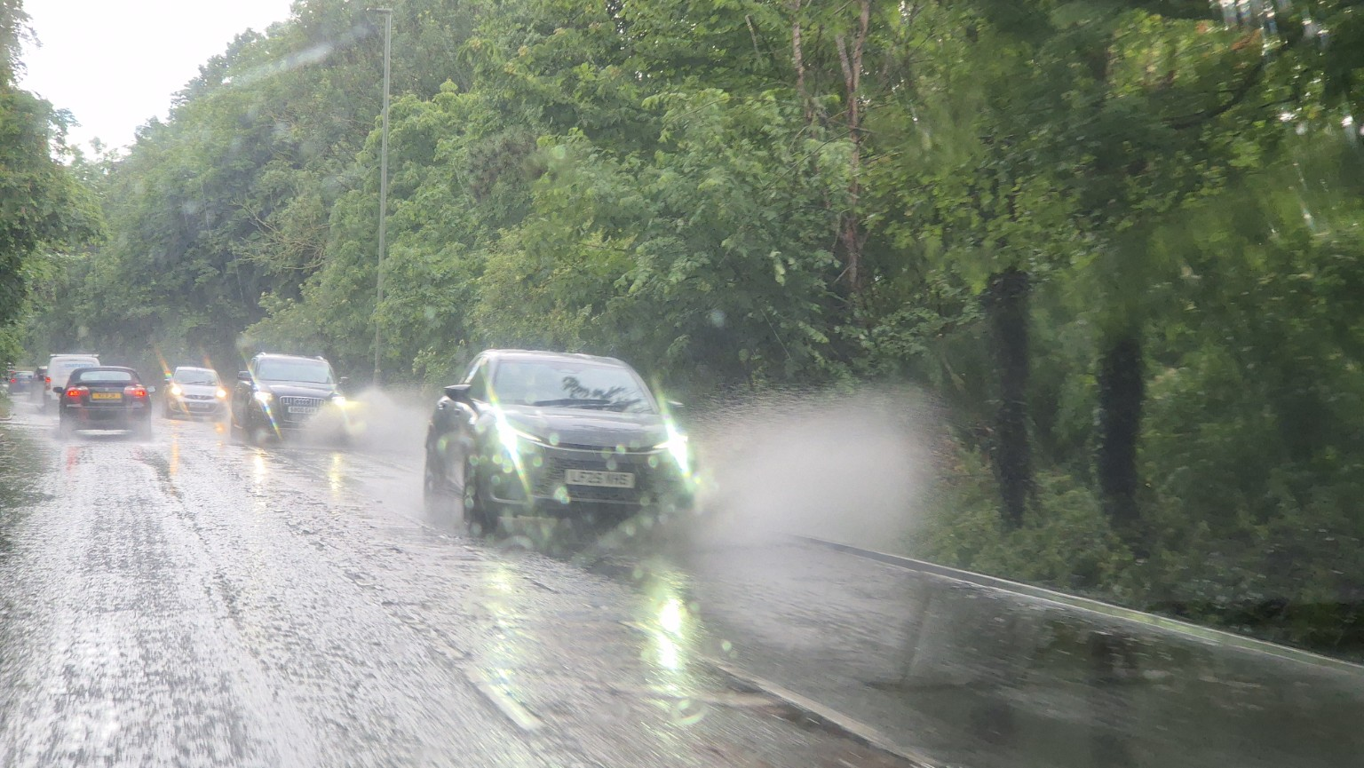
Vehicles travelling through pooled surface water on Reigate Road, reported as taken on 06/02.

Appendix B – Resident Photographic Evidence of Wildlife

The following photographs are resident observations of wildlife on or around Downs Farm and the surrounding area. The photographs support the need for proper site-specific ecological surveys, including surveys for protected and priority species and assessment of ecological connectivity across the wider chalk landscape.

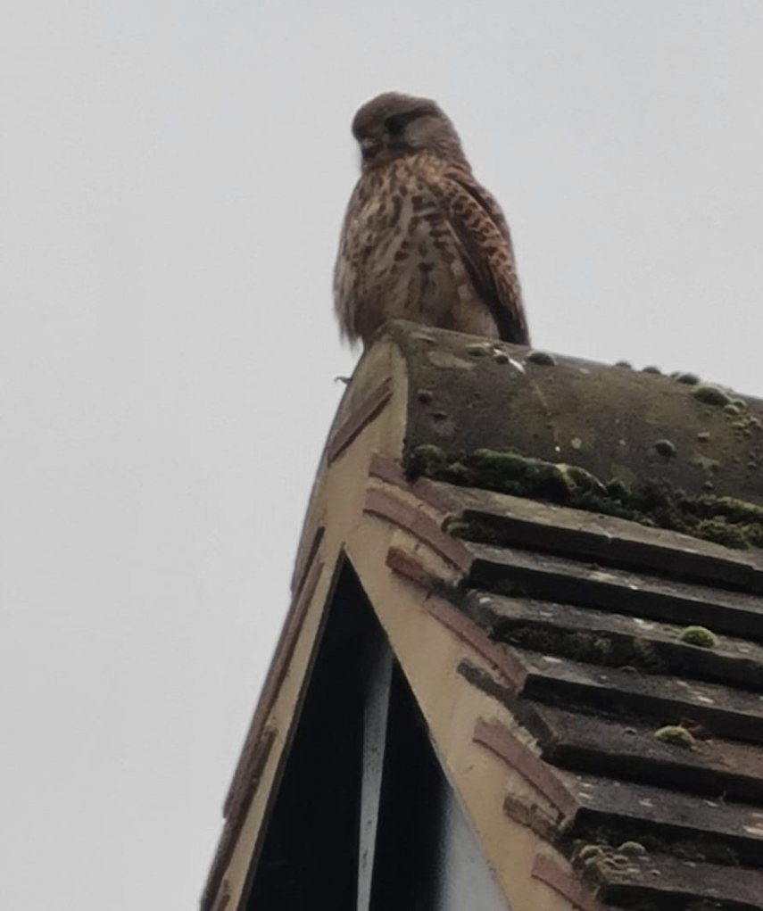
Resident photograph of a bird of prey / raptor observed locally.
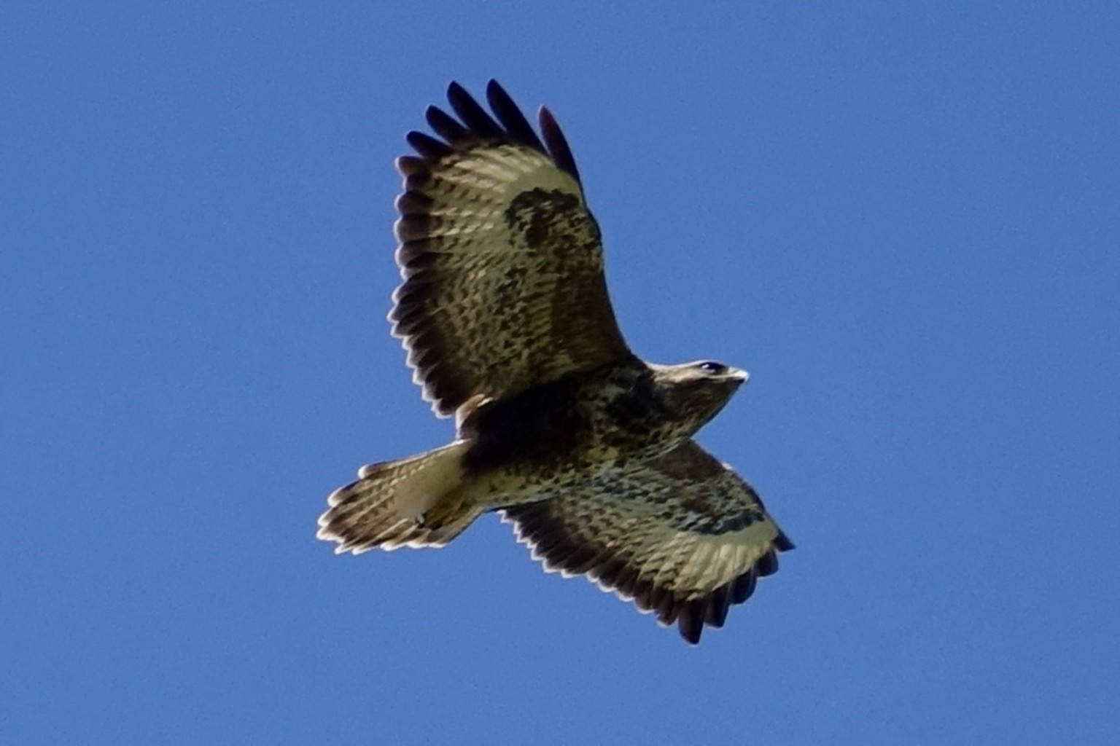
Resident photograph of a bird of prey / raptor in flight observed locally.
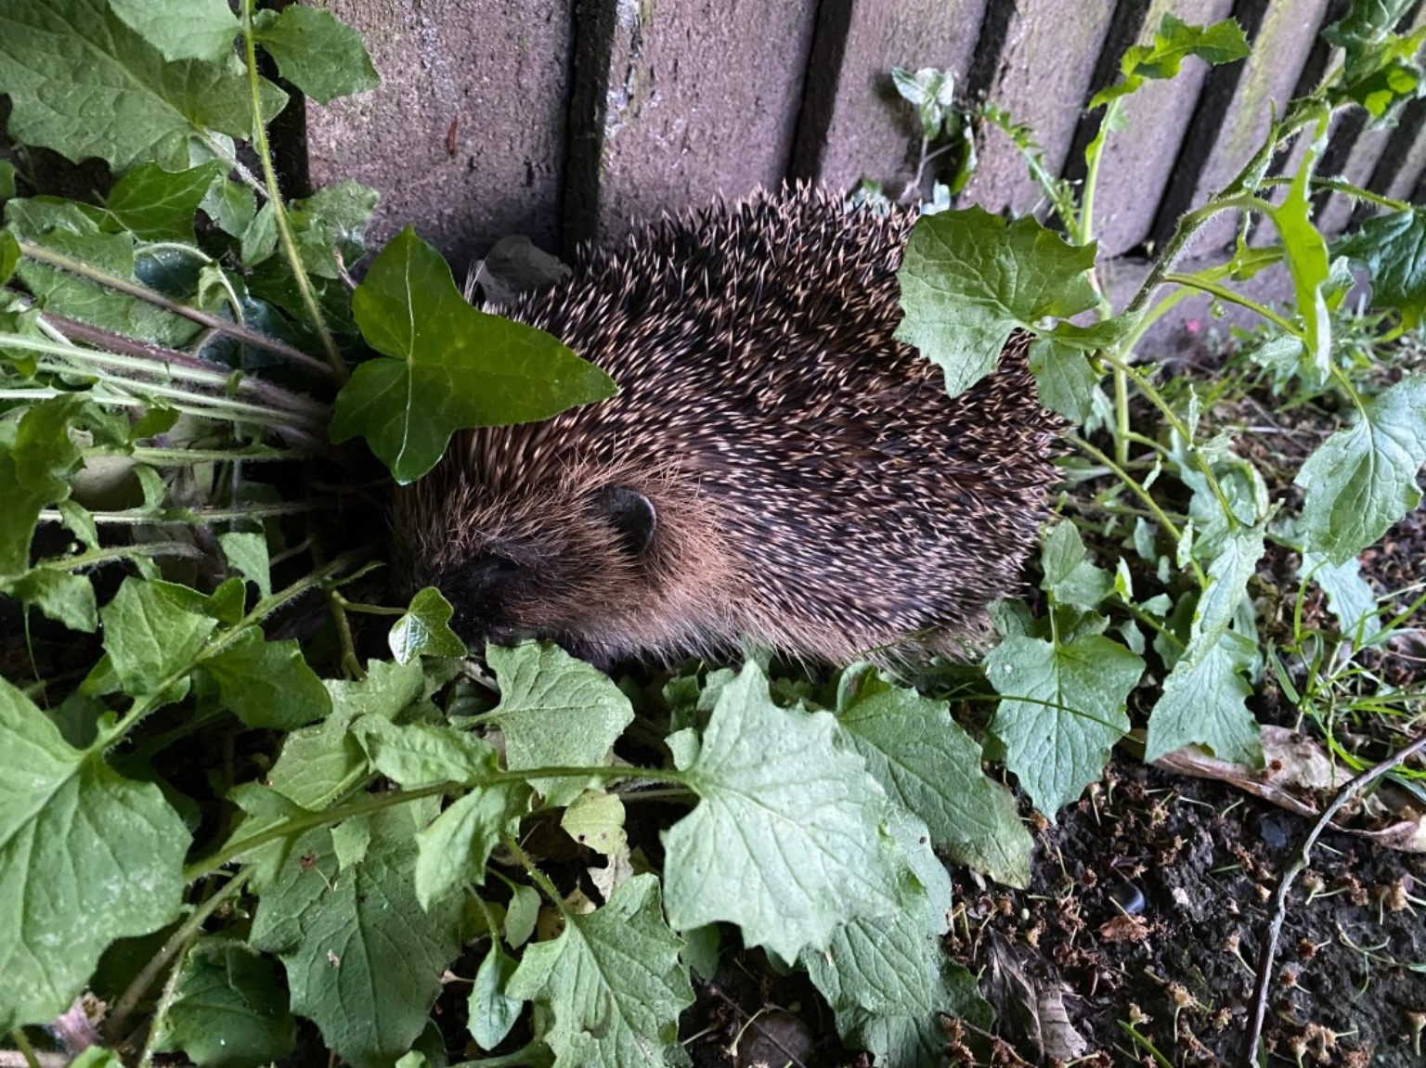
Resident photograph of a hedgehog observed locally.
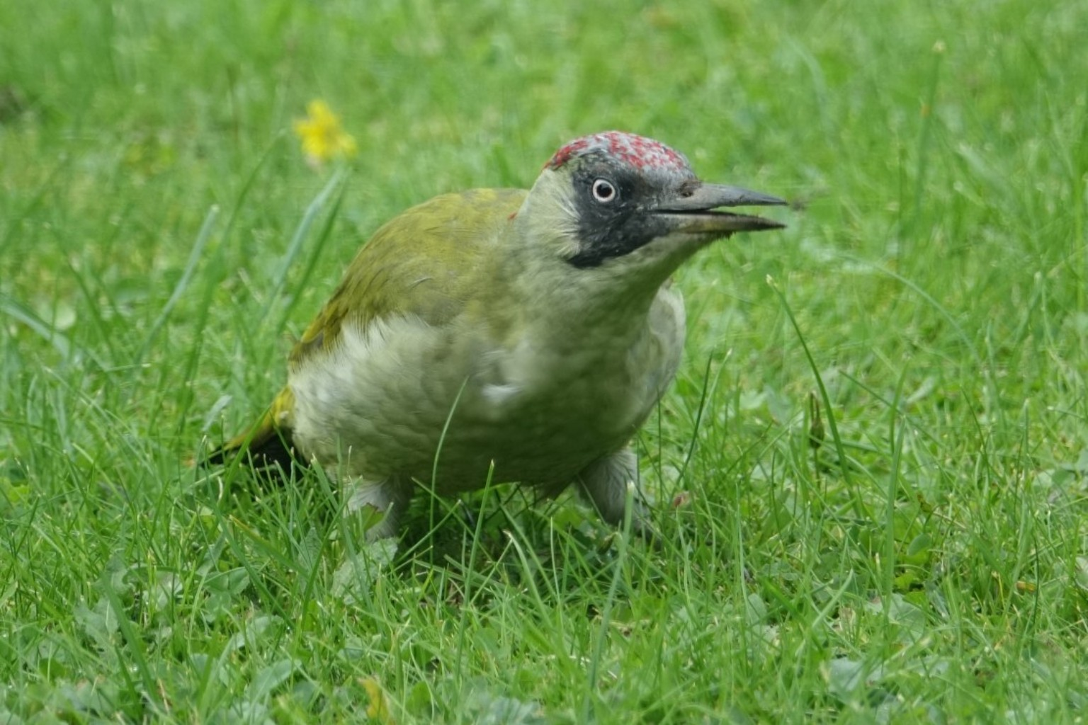
Resident photograph of a woodpecker observed locally.

Resident photograph of a heron observed locally.
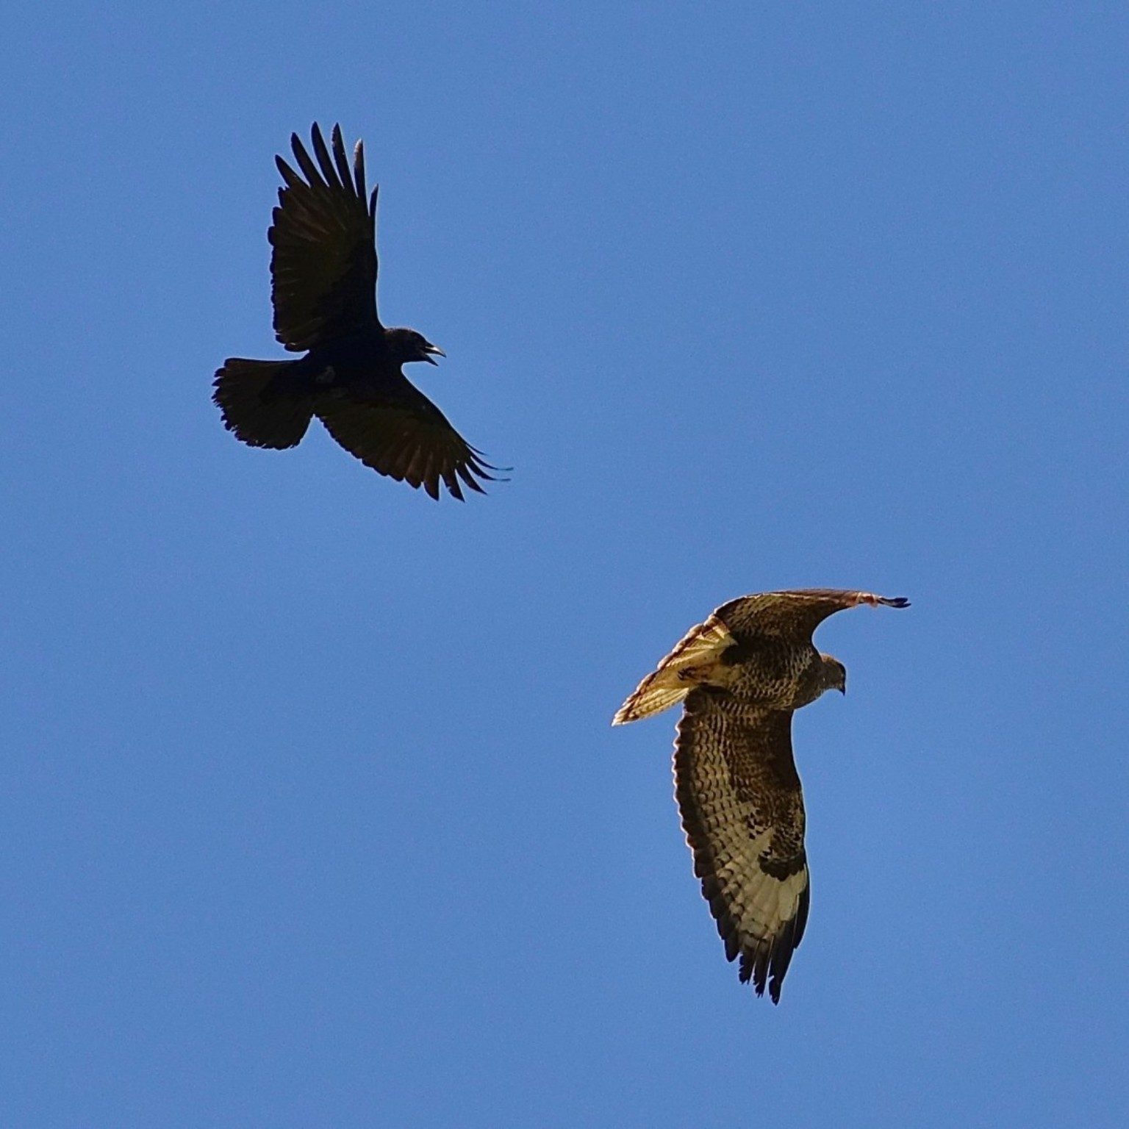
Resident photograph of birds observed locally, including a bird of prey / raptor.

Appendix C – Heritage / Pillbox Evidence
Downs Farm contains a surviving Second World War pillbox associated with the Outer London Defence Line. This is recorded by the Archaeology Data Service and should be taken into account as part of a wider archaeological and heritage assessment before any allocation decision is made.
Archaeology Data Service record: https://archaeologydataservice.ac.uk/archives/view/dob/ai_full_r.cfm?refno=16790

(Continue on a separate sheet / expand box if necessary)
Please note your representation should provide succinctly all the evidence and supporting information necessary to support your representation. You should not assume that you will have a further opportunity to make submissions.
After this stage, further submissions may only be made if invited by the Inspector

6. Do you consider it necessary to participate in a potential further examination hearing session(s)?
☐ No, I do not wish to  participate in  hearing session(s) |  |  |  |  | ☒ Yes, I wish to participate in  hearing session(s)
Please note that while this will provide an initial indication of your wish to participate in hearing session(s), you will need to confirm your request to attend with the Programme Officer by the close of the consultation by emailing: bankssolutionsuk@gmail.com

7. If you wish to participate in a potential future hearing session(s), please outline why you consider this to be necessary:
I respectfully request the opportunity to participate in the Examination Hearing Sessions concerning the proposed allocation of Downs Farm.
My representation raises matters relating to the soundness of the Plan, including Green Belt exceptional circumstances, transport impacts, biodiversity, flood risk, infrastructure capacity, sustainability appraisal methodology and procedural fairness.
Downs Farm is a highly sensitive Green Belt site which has generated significant public concern. I believe these issues would benefit from discussion at the hearing, where I can assist the Inspector by providing local evidence and responding to questions regarding the practical implications of the proposed allocation.
Given the complexity of the matters raised, I do not believe they can be fully explored through written representations alone. My participation would therefore assist the Examination in testing whether the Plan is justified, effective and consistent with national policy.

Please note the Inspector will determine the most appropriate procedure to adopt to hear those who have indicated that they wish to participate in hearing session(s).

