The efforts of the team of volunteers together with winter grazing by cattle have resulted in the reserve turning into prime chalk grassland which is a rare and precious habitat with a unique biodiversity.
SWT has just spent a large amount of money upgrading the fencing of the grazed areas. This fencing should last for more than thirty years and allow more flexibility with future grazing including the use of sheep as well as cattle.
The site also includes some very extensive chalk scrapes. These are areas where there is very little topsoil and this creates the ideal conditions for some very rare and special plants and animals.
For example these scrapes are very important for the Small Blue butterfly, a declining UK species.
https://butterfly-conservation.org/butterflies/small-blue
The sole larval foodplant is Kidney Vetch and this grows superbly well at Priest Hill. A Butterfly Conservation project, the Surrey Small Blue project, started in 2017 with the aim of creating more sites along the North Downs by creating scrapes and seeding with Kidney Vetch seed. Much of this seed was obtained from Priest Hill because it was growing so abundantly there. The yellow flowers in this photo are of Kidney Vetch flowering in 2018.
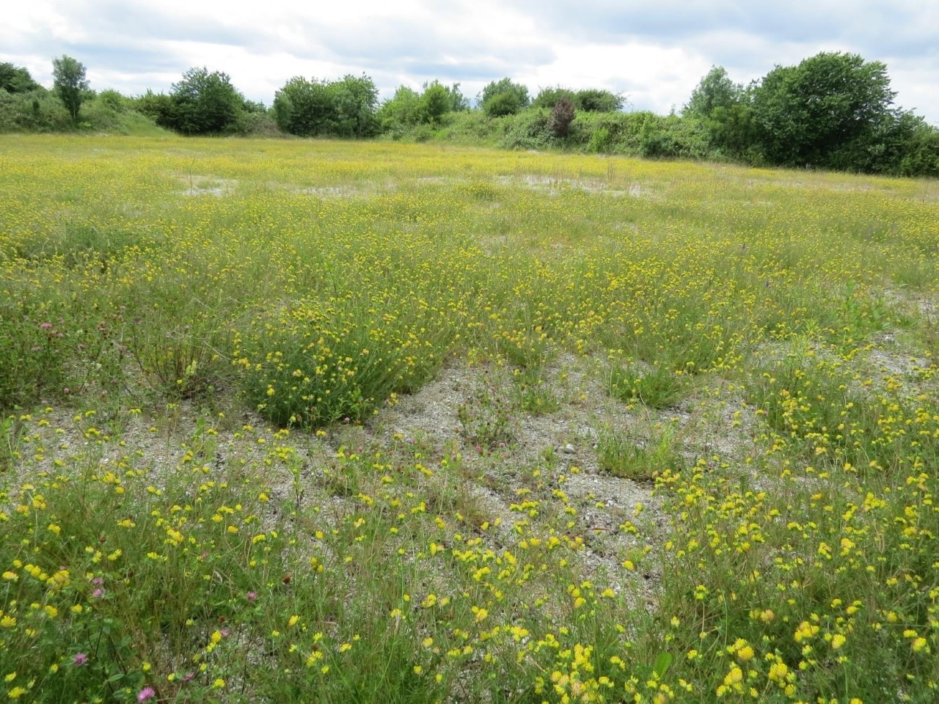

The site is also being used to cultivate some of Surrey’s rarest plants.
SWT obtained permission from Natural England to translocate some of these plants to Priest Hill.
Broad Leaved Cudweed only exists in about a dozen sites nationally and has since the translocation been lost at the donor site.
Cut leaved Germander only exists at about six sites nationally and has now been lost at the donor site. Priest Hill is now the only Surrey site.
Orchid species are becoming established in the ideal conditions on the site.
So far Bee Orchid, Common Spotted Orchid, Pyramidal Orchid and White Helleborine have appeared.

The site is also important for bird life.
More uncommon breeding birds include Skylark, Common and Lesser Whitethroat, Blackcap and Kestrel. Visiting birds include Meadow Pipit, Stonechat, Whinchat, Dartford Warbler, Snipe, and even Ring Ouzel.

Moth trapping has shown the site to be particularly interesting. Last August around 160 species were recorded one night. We are planning further sessions this spring and summer.

Reptile monitoring has revealed Grass Snake and Common Lizard are present.

Mammals on include Deer, Fox, Badger, Field Vole, Pygmy Shrew, and Bats of several species.

I hope this gives a flavour of how important Priest Hill is for biodiversity.

In terms of how the proposed development would impact the reserve there are several points to be made.

Firstly the impact of buildings so close to the reserve would be enormous simply from light and noise pollution particularly on nocturnal creatures such as bats, moths and other invertebrates.

Secondly the inevitable increase in visitor numbers would be very damaging.
Already the site suffers from quite high numbers of dog walkers with associated nutrient enrichment of the soil and possible effects of flea and tick treatments on dogs causing contamination of the grassland and soil. An increase in dog numbers would exacerbate these problems and potentially impact the use of sheep grazing through the risk of dog attacks. The presence of cats would also be very damaging.
The site has also suffered from some anti-social behaviour.
For example there are areas of the site that are not open to the public and these areas include five wildlife ponds. There has been regular vandalism of these ponds. On the periphery of the site there is an area of ancient woodland. This has been used as a drinking den with large amounts of rubbish discarded there and trees cut down to make large bonfires.
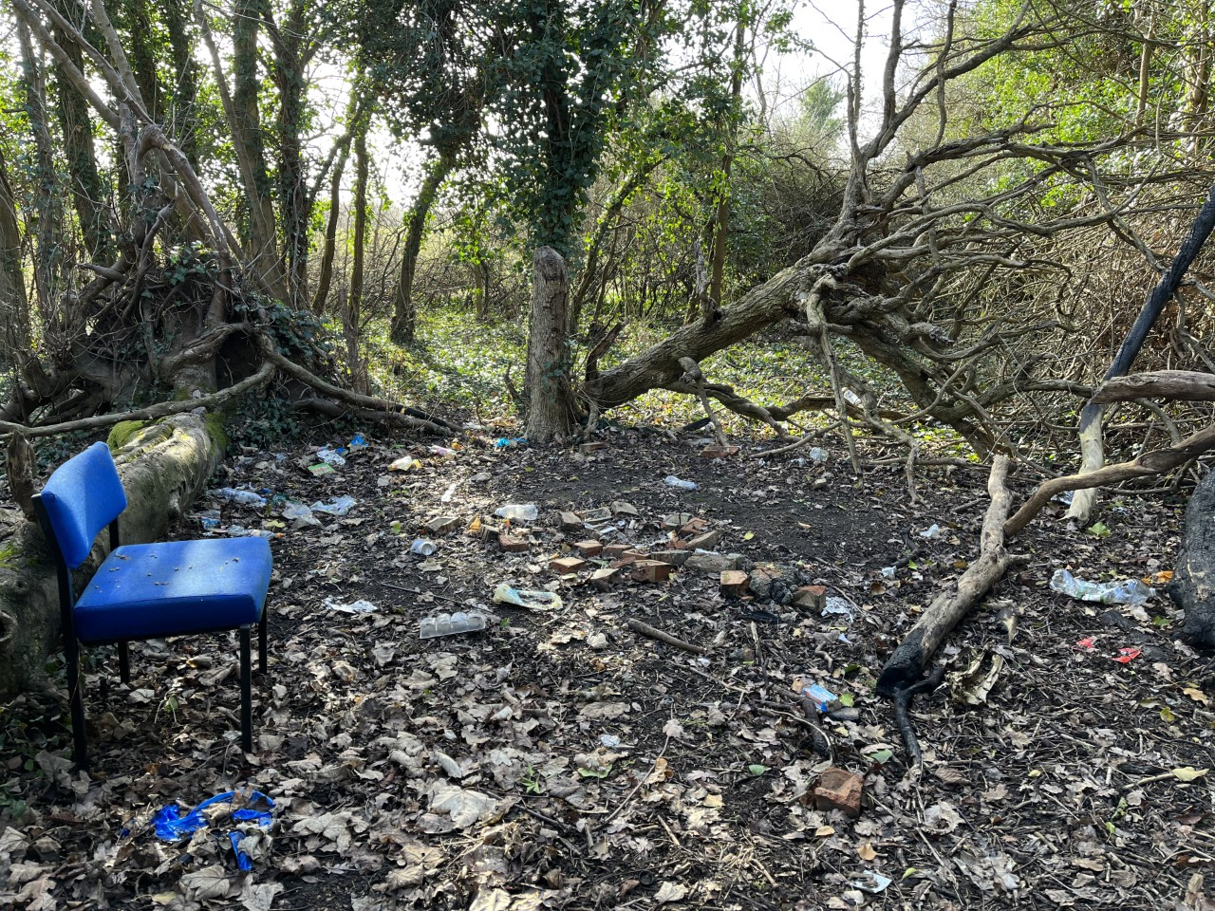

Mini motorbikes have also caused damage to areas of the scrapes where Broad Leaved Cudweed is growing and bonfires have been made in the woodland adjacent to the Banstead Road entrance with trampling of the White Helleborine orchids.
These problems would be vastly worse with so many more people living so close by.

One final point about the draft local plan.
The headline figure of 3.6% of green belt land to be developed is extremely misleading in terms of impact. The area of land to be used for the Priest Hill development is 8.63 hectares but this would effectively ruin the 35 hectares of the reserve. Similar arguments apply to other sites particularly the impact of the Horton Farm development on Horton Country Park.

The local plan takes no account of damage to biodiversity corridors.
Howell Hill, Northey Fields and Priest Hill are currently being considered as a new local nature reserve. They form a green link together with North Looe farm and Downs View farm to Epsom Golf Course and Epsom Downs.

